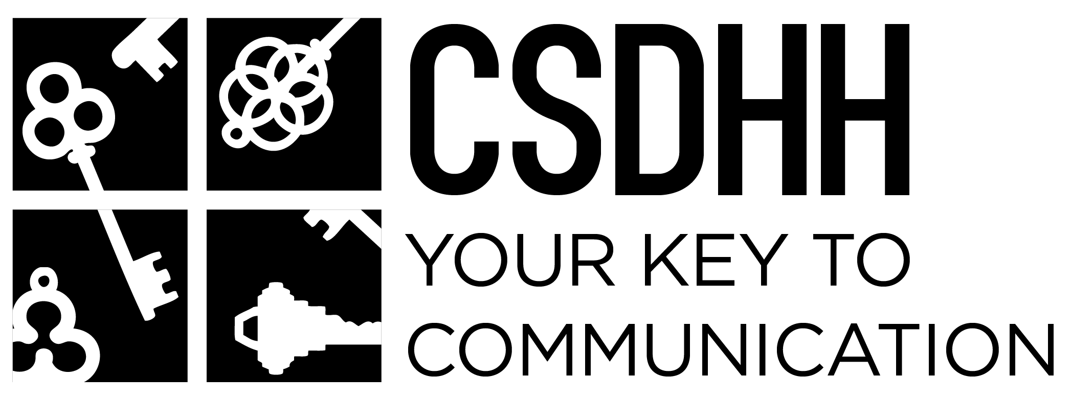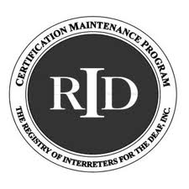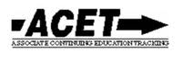
Wink
“Make the English Tangible in ASL”
WORKSHOP OVERVIEW
This workshop applies visual-spatial techniques in order to better produce visual language. ASL has more than simple lexical signs and fingerspelling, which make up the “tell” options. Some of the “show” options come in the form of depiction. Depiction is a topic that has made quite a stir among researchers in ASL linguistics. It includes depicting verbs, surrogation, partitioning, blending, affect, mouth morphemes, other non-manual signals, and networking. Using these aspects of ASL, interpreters can create clear and powerful ASL messages that create a bridge between consumers.
When we see how Deaf people developed ASL, and how it has evolved into the complex language it is today, we see much of that was due to their subjective knowledge and experiences. This workshop encourages participants to think about the objects and required actions in a sentence in order to formulate an ASL concept based on their experiential views of the world, and do so without imposing their own biases. This framework takes English and makes it tangible in ASL. *Presented in ASL*
EDUCATIONAL OBJECTIVES:
By the end of this workshop, participants will be able to…
1. Draw from their experiences to construct ASL concepts
2. Provide examples of how to “show” a concept, rather than “tell” it.
3. Define ASL depiction techniques, and apply them to English text translations.-List several ways they can better incorporate emerging standard practice into their work.
-Support their practice decisions when interacting with other professionals.
- Access reference resources pertaining to standard practices and competencies.
-Identify differences between our professional code of conduct and standard practice.
Led By: | Windell "Wink" Smith
Date & Time | Saturday April 23rd 2016
Cost | NCRID Members $50*, Non-members $60*, Students $10*, At the door $75
Location | UNCG School of Education, Room 118, 1300 Spring Garden St, Greensboro NC 27403
- *Prices will go up $10 after April 8th
- Please contact Kelle@csdhh.org with accommodations requests at least 10 days before the event.
- CEUs are sponsored by NCRID. NCRID is an Approved RID CMP Sponsor for Continuing Education Activities.
- Register online at http://csdhhworkshops.eventbrite.com
- This PS workshop is offered at a total of 0.6 PS CEUs at the “Some” Content Knowledge Level.
- This workshop is designed for Interpreters who wish to incorporate more depiction into their signed message.
REFUND AND CANCELLATION POLICY
Cancellations must be received 10 days prior to the event for a full refund, cancellations received after that time will not be refunded. In the event NCRID has to cancel the event, full refunds will be issued.

