Emerging Community; Emerging Techniques  Deaf-Blind Training Weekend  Hosted by: The North Carolina Deaf-Blind Associates  When:  August 5 – 7, 2016  Starting Friday at 4:30pm & Ending 4:00pm Sunday  Where  The Summit at Haw River State Park  339 Conference Center Drive, Brown Summit, NC 27214  Purpose: This weekend course is for those seeking to become qualified in working with Deaf-Blind individuals as interpreters or Support Service Providers (SSPs)  OBJECTIVES: (2.0 CEUs including pre-work)  • Overview of Deaf-Blindness and Communication Modalities  • SSP and Deaf-Blind Interpreter roles and responsibilities  • Human Guiding Techniques  • Prioritizing and Providing Visual Information  • Touch Signals  • Linguistics and Tactile ASL Modifications  • Logistics and Coordinating communication support for a diverse Deaf-Blind audience and much more...  presenters:  Ashley Benton, LCSW, MSW - DSDHH Deaf/Deaf-Blind Services Coordinator  Jeff Trader, NCICS: A, RID CI & CT - Sign Language Interpreter  Marilyn Trader, MSW - HKNC Southeast Regional Representative  Lee Williamson, NCICS: A, RID CI & CT-DSDHH Communications Access Manager  Sign Language interpreters will be provided  voicing and signing |  |  | ATTN:  Interpreters &  Service Providers  Cost Covers Registration, Lodging, Meals  Commuter: $125 (not staying on campus, all meals provided except breakfast)  Double room rate: $225 (sharing a room)  Single room rate: $265 (no roommate)  How to register: FILL OUT THE REGISTRATION FORM ON THE BACK AND RETURN TO dsdhh. Any questions regarding this event, please email: Janetta.Hall@dhhs.nc.gov  Benefiting  The NCDBA, DB Community, Professionals & Service Providers  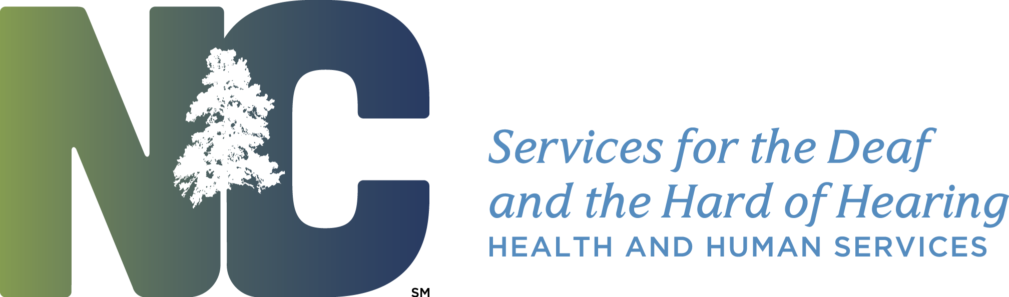

Emerging Cultures; Emerging Techniques
Deaf-Blind Training Weekend
Hosted by the North Carolina Deaf-Blind Associates

REGISTRATION FORM

Name: _________________________________________________________

Street Address: _________________________City:__________ State:________

Home Phone: __________________ (V), (VP) Cell Phone: ____________________

Special Accommodations: ___________________________________________

Registration:
Commuter: _____________ Single Room: __________ Double Room: __________

Mail Registration:
DSDHH
c/o Janetta Hall
2301 Mail Service Center
Raleigh, NC 27699-2301

* Upon receipt of this your registration a confirmation letter will be sent with further instructions pertaining planning for this event.

