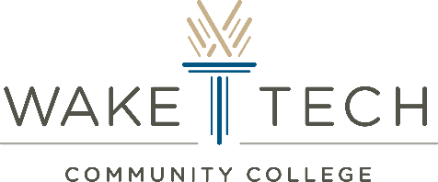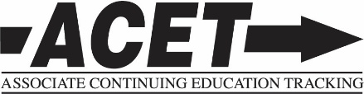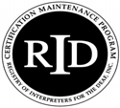

**Workshop Description:**

Lawrence Shockey will begin our workshop by touching on various laws that affect sign language interpreters increasing awareness of laws at the local, state, and federal level. In addition to describing each law, and he will explain how each applies to the work of sign language interpreters. He will share stories from his wealth of personal experience and perspective. In the afternoon portion of the workshop, Lawrence Shockey, Pam King, and Deborah Leisey will facilitate a discussion as we apply what we learned that morning to several scenarios. Through group discussions we will practice explaining our services in relation to what the law requires.

**Lawrence Shockey**:

Interpreting Services Specialist, DSDHH Raleigh Regional Center

Lawrence has worked as the Interpreting Service Specialist with the NC DSDHH since 1998 and has been a NC licensed interpreter since 2005. Previously he was employed by VR and Dorothea Dix Hospital where he started his career working with people who are Deaf, Hard of Hearing and Deaf-Blind.

Lawrence’s involvement with persons of different abilities is not just an 8-5 job. He is the proud father of four (4) adopted children, each of whom have a different ability, one of whom is Deaf with Autism. In 2001, he was appointed by the Governor to the NC Council for Developmental Disabilities. He was also involved with setting up the first Arc of Johnston County, served as a disability consultant for Johnston County’s Guardian Ad Litem program, volunteered to assist a special education attorney, served as liaison for DSDHH to TRID and from 2007 to 2013, administered his own home school to meet the special needs of his child. Lawrence truly eat, sleeps and breathes in the world of disabilities.

**Awareness and Application of Laws Affecting Interpreters**

**Presenter: Lawrence Shockey**

**ff**

**April 29, 2017**

8 A.M. Registration

9:00 A.M.-4:00 P.M. Workshop

Lunch provided.

.6 PS CEUs

**Location:**

Wake Technical

Community College

9101 Fayetteville Road

Raleigh, NC 27603

Building: Pulcher LeMay

Room: PLM 241

Parking Instructions:

Parking is open on the weekends without regard to staff or student designation.

**“Awareness and Application of Laws Affecting Interpreters”**

**Workshop Information**

**Language of Presentation:**  This training will be conducted in English. Interpreters will be provided upon request. **For accommodations** contact Lawrence Shockey at 919-859-8526, ext. 3 or lawrence.shockey@dhhs.nc.gov by April 17, 2017.

**Refund and Cancellation Policy:** All refund requests **must** be in writing. The requests should be emailed to Lee Williamson at [lee.williamson@dhhs.nc.gov](mailto:lee.williamson@dhhs.nc.gov). No refunds, except for medical emergencies, will be issued past April 20, 2017.

**CEUs:** NCRID is an Approved RID CMP Sponsor of Continuing Education Activities.

.6 Professional Studies CEUs at the selected Content Knowledge Level:

___Little/None **X Some ___**Extensive  **___**Teaching

**Target Audience:**  Open to all interpreters.

**Registration Cost:**

Registration will be accepted until April 20, 2017, or until full.

Regular Rate (postmarked by April 20th): $50. 00 After April 20th: $65.00

Student Rate (postmarked by April 20th): $25.00 After April 20th: $40.00

* Students must submit a copy of their student ID.
* Students in ITP’s or deafness related degrees are welcome.

Payments must be made by check or money order, payable to “DSDHH.”

DSDHH cannot accept cash, including if you are registering and paying at the door.

**Registration Form for**

**“Awareness and Application of Laws Affecting Interpreters”**

**with the Raleigh Regional Center**

**and Wake Technical Community College**

Please send this form and check or money order payable to **DSDHH.**

**Send to:**

Janetta Hall

“Laws and Interpreters” Workshop

NC Division of Services for the Deaf and Hard of Hearing

2301 Mail Service Center

Raleigh, NC 27699-2301

Name: _________________________________________________________________

Address: _______________________________________________________________

________________________________________________________________________

Phone: _________________________________________________________________

Email: __________________________________________________________________

NCITLB License Number (if any): _____________________________________________

**Registration Cost:**

Registration will be accepted until April 20, 2017, or until full.

Check or money order payable to “DSDHH.” No cash, please.

Regular Rate (Postmarked by April 20th) After April 20, 2017

Registration Fee: ______ $50.00 _____ $65.00

Student Fee: ______ $25.00 _____ $40.00

Amount enclosed: $__________________________________________

**________________________________________________________________________**

**DSDHH Office Use Only**

Date postmarked: ____________ Amount received: _____________ Check number: ______________