Support Service Provider (SSP) Orientation Training

N.C. Division of Services

for the Deaf and the Hard of Hearing

**The first step to becoming an SSP**

When: Saturday, February 4, 2017

Time: 9:00 a.m. – 4:00 p.m.

Site: UNC-G, School of Education Building

Room #118

1300 Spring Garden Street

Greensboro, NC 27412

**Presenters:**

* Ashley Benton, DSDHH Deaf/Deaf-Blind Services Coordinator
* Marilyn Trader, Helen Keller National Center, Southeast Regional Representative

Come explore your awareness, thoughts and perceptions associated with working with Deaf-Blind people.

After completing the session, participants will:

* Have basic understanding of the diversity within the Deaf-Blind community.
* Have a clear understanding of SSP/Interpreter roles and responsibilities and what is expected of them.
* Be able to incorporate human guiding techniques.
* Be able to provide visual information.
* Have access to national and state resources.

Limited seating (40), please *RSVP by January 27, 2017.

*RSVPs to: Janetta Hall, V 919-874-2212; VP 919-890-0859

Email: [Janetta.hall@dhhs.nc.gov](mailto:Janetta.hall@dhhs.nc.gov)

***Other accommodation requests to:

Ashley Benton: VP 919-741-4511

Email: [Ashley.benton@dhhs.nc.gov](mailto:Ashley.benton@dhhs.nc.gov)

Refreshments and drinks will be served.

Lunch will be on your own.

**A FREE workshop for:**

Deaf Studies and ITP students

Those who want to learn more about the Deaf-Blind community.

Potential SSPs

Interpreters

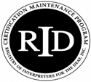

.6 CEUs available with $10.00 fee for non-NCRID members

***Interpreters provided***

Every attempt will be made to inform participants immediately if cancellation of the workshop occurs.

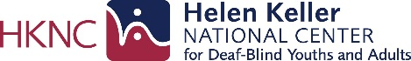

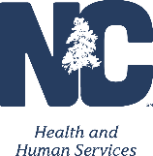

State of North Carolina • Department of Health and Human Services

Division of Services for the Deaf and the Hard of Hearing

www.ncdhhs.gov • www.ncdhhs/dsdhh

N.C. DHHS is an equal opportunity employer and provider 01/16